Week 3 Report: Real-World Mini Project
Adjustable Phone / Tablet Stand
Prepared by: Nimrah Saleem | Department of Electronic Engineering, NED University

1. Objective
This week's task required planning and building a small end-to-end mini project independently, applying CAD design, design calculations, and engineering drawing skills from the previous two weeks without step-by-step guidance. An adjustable phone/tablet stand was chosen as a simple, practical mechanical design problem.

2. Problem Statement
A phone or tablet needs to be propped up at a comfortable viewing angle for tasks like video calls, watching videos, or reading recipes. A single fixed angle does not suit every situation (e.g., low table vs. high table, landscape video vs. typing). The stand must therefore support at least 2–3 distinct viewing angles, hold the device securely without slipping, and remain stable (not tip over) at every angle.

3. Proposed Design
The stand consists of two simple flat parts:
- Base Plate — a flat platform with a raised front lip to stop the phone sliding off, and a slot in the middle.
- Back-Leg — a flat panel with a tab at its base and three notches along its edge. The tab inserts into the base slot, and the notch used determines the recline angle.
Moving the leg's tab to notch 1, 2, or 3 changes the support angle to approximately 20°, 35°, or 50° from horizontal, giving the user three selectable viewing positions with a simple, tool-free adjustment.
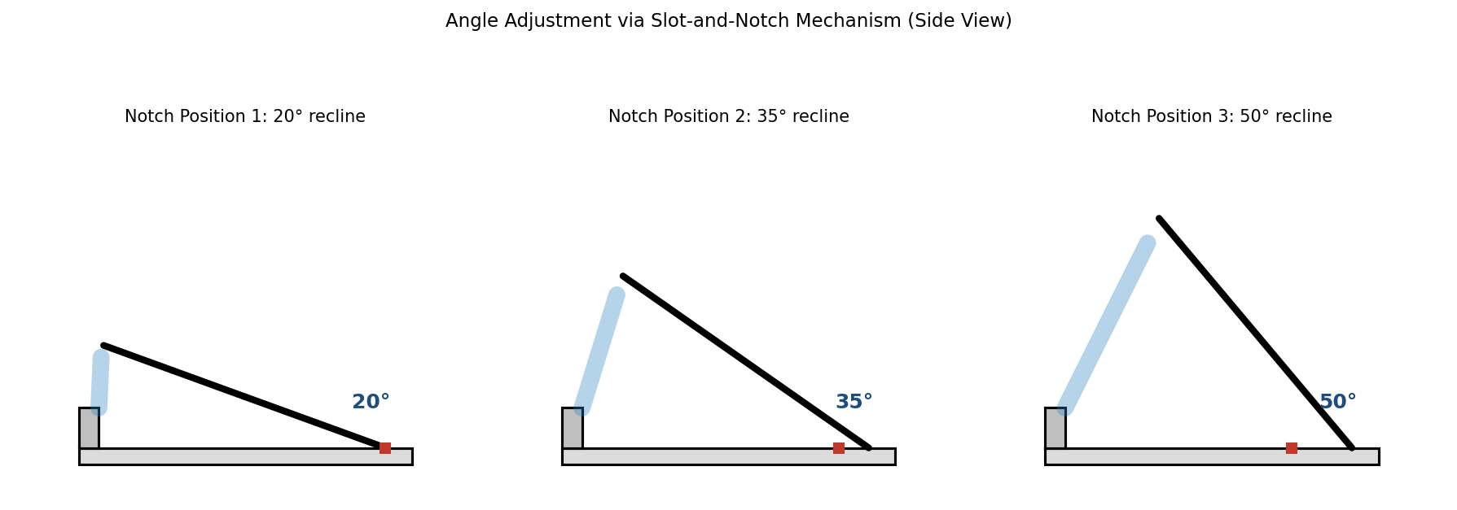
Figure 1: Angle Adjustment via Slot-and-Notch Mechanism (Side View)

4. CAD Design of the Stand
The two-part design was modeled with the dimensions below, keeping the part count low and the geometry simple enough to cut from acrylic/plywood (laser cutting) or 3D print. Multiple views are included below so the design is clear from every angle.
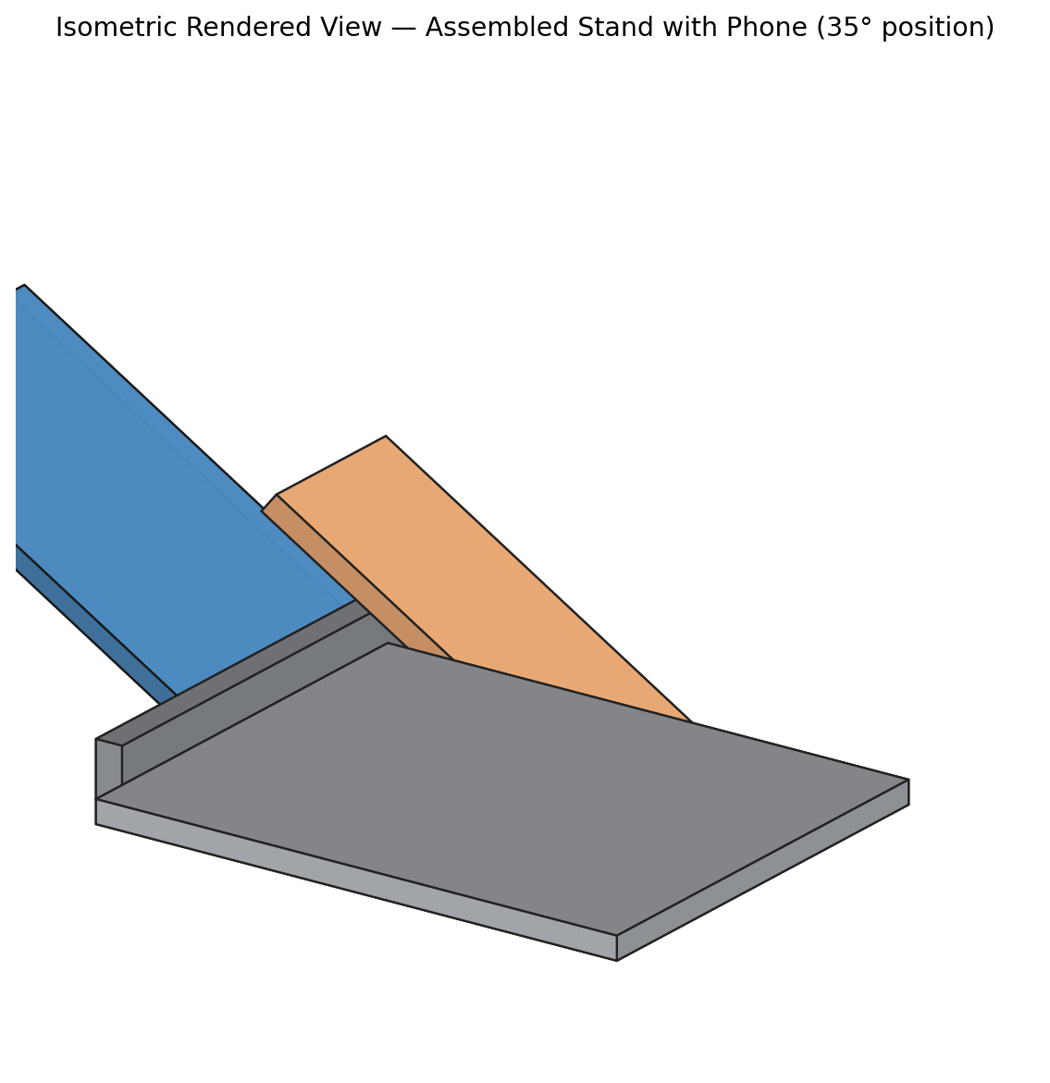
Figure 2: Isometric View — Assembled Stand with Phone (35° position)
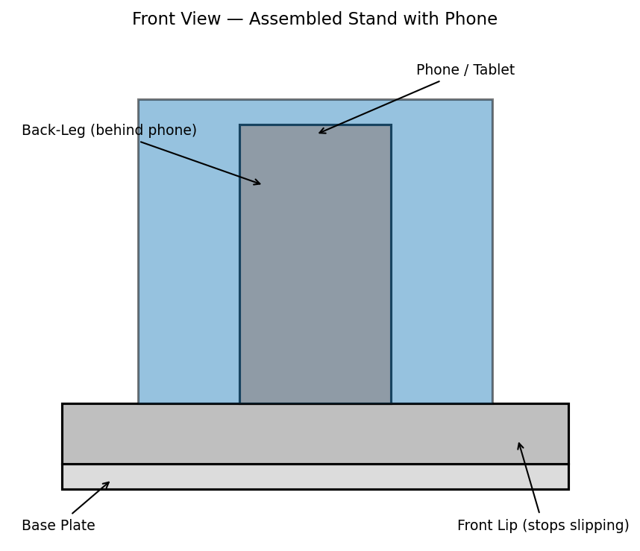
Figure 3: Front View — Assembled Stand with Phone
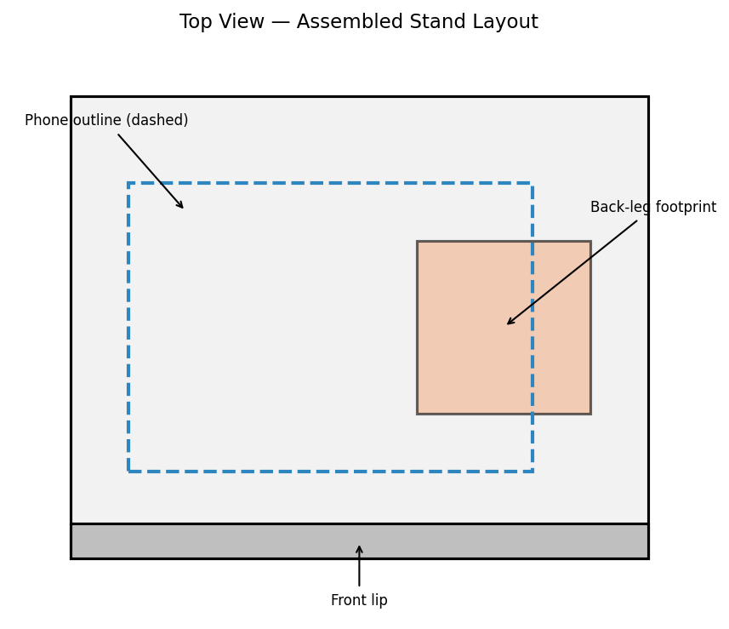
Figure 4: Top View — Assembled Stand Layout

5. Engineering Drawing
Dimensioned views of both parts are shown below. All dimensions are in millimeters.
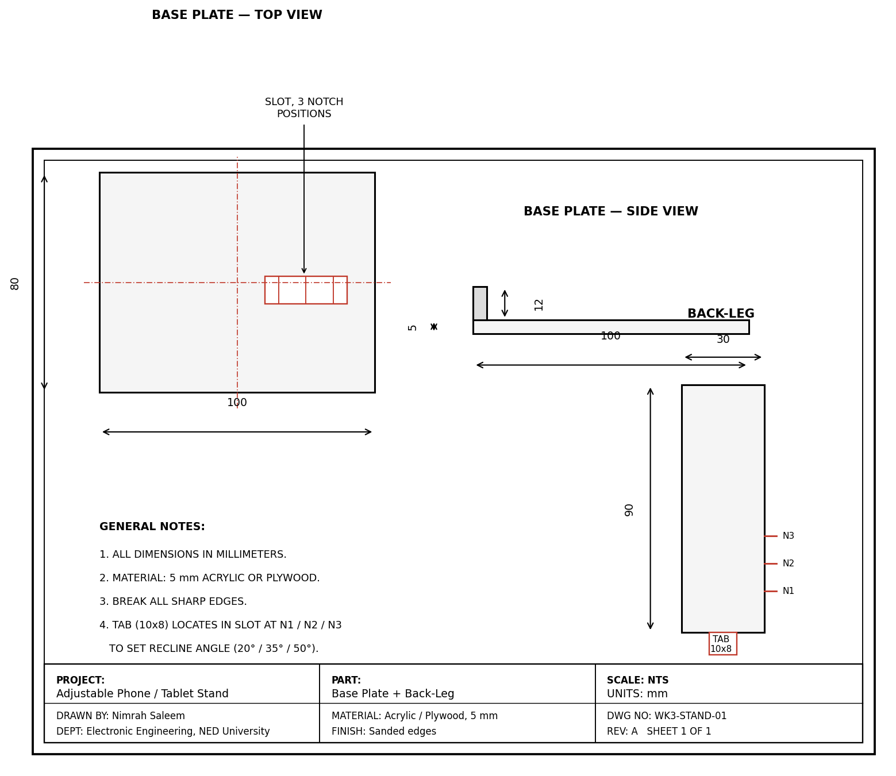
Figure 5: Dimensioned Drawing — Base Plate and Back-Leg
The close-up below shows how the back-leg's tab engages one of the three notches in the base slot to lock the chosen angle.
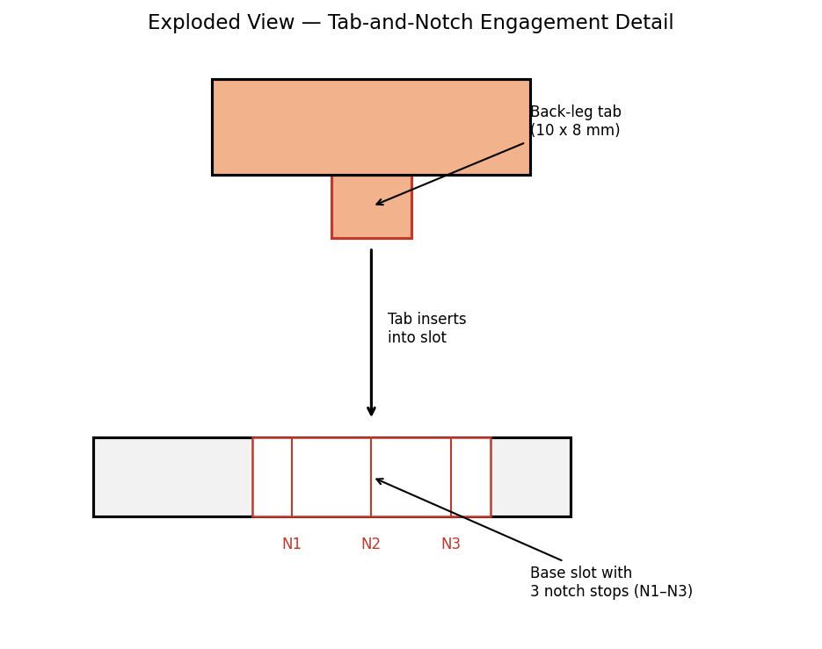
Figure 6: Exploded View — Tab-and-Notch Engagement Detail

6. Design Calculations
- Base footprint: 100 mm (L) × 80 mm (W) — defines the tipping limits at x = 0 (front) and x = 100 mm (rear).
- Assumed phone weight: 0.20 kg; stand weight (acrylic, ~5 mm thick): approx. 0.15 kg.
- Combined center of gravity (C.G.) was estimated by taking a weighted average of the base, leg, and phone positions along the length of the stand.
- Stability condition: the combined C.G. must fall between x = 0 and x = 100 mm (within the base footprint) at every notch angle, or the stand will tip.
- At all three notch angles (20°, 35°, 50°), the calculated C.G. position remained between x ≈ 30–40 mm, well inside the 0–100 mm support range — confirming the design is stable at every position.
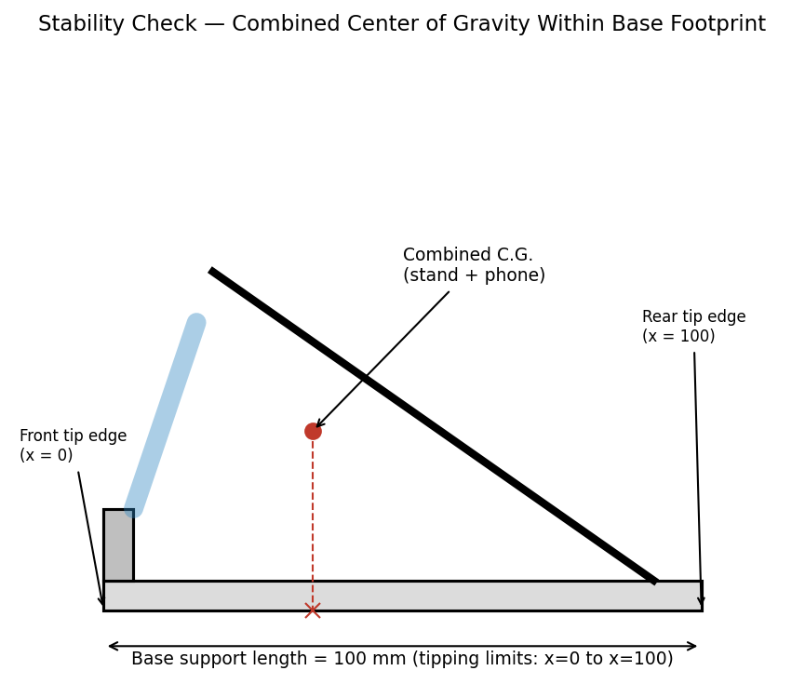
Figure 7: Stability Check — Combined Center of Gravity Within Base Footprint

7. Build and Assembly Steps
- Cut the base plate and back-leg from the chosen material (5 mm acrylic or plywood) per the drawing in Figure 3.
- Cut the slot in the base plate and the three notches on the back-leg edge.
- Sand all edges smooth, especially the phone-contact edge of the front lip.
- Insert the back-leg tab into the base slot at notch 1 and check the phone sits securely at that angle.
- Repeat the check for notch 2 and notch 3, confirming the stand does not tip or wobble at any position.
- Test with the actual phone/tablet to confirm fit, grip, and stability under real use.

8. Design Justification
- Two-part slot design chosen over a hinge to avoid needing screws, springs, or extra hardware — simpler to build and more durable for a first mini project.
- Three fixed notches (rather than continuous adjustment) keep the mechanism simple while still covering low, medium, and high viewing angles.
- 100 mm base length was chosen specifically so the combined C.G. stays well within the footprint even at the steepest 50° angle, prioritizing stability over a smaller footprint.

9. Conclusion
This mini project combined CAD design, dimensioning, and stability calculations from Weeks 1–2 into one independent, end-to-end design task. The final design is simple enough to build with basic tools, holds a phone or tablet securely at three selectable angles, and was verified for tip-over stability at each position before finalizing the drawings.

